Date: 23 August 2016
From: Small Cell Forum
Contact: Richard Kennedy (richard@smallcellforum.org) SCF COO & IEEE Liaison Officer
Mark Grayson (mgrayson@cisco.com) SCF Virtualization co-lead
Neil Piercy (Neil.Piercy@ipaccess.com) SCF Virtualization co-lead
To: IEEE 1914 Next Generation Fronthaul Interface (NGFI) WG

Liaison Subject: Functional Partitioning and Virtualized Small Cells

1. Introduction
Small Cell Forum (SCF) understands that IEEE 1914 Next Generation Fronthaul Interface (NGFI) Working Group was formed recently to develop a standard for Packet-based Fronthaul Transport Networks and that it is planning on analyzing functional partitioning schemes between Remote Radio Units (RRUs) and Base-Band Units (BBUs) that improve fronthaul link efficiency and interoperability.
The SCF has been studying the issue of functional partitioning as it relates to virtualization of the RAN, specifically as it applies to the deployment of small cells for over 2 years, and would like to share the following information with the IEEE 1914 Working Group.

2. Study into Small Cell Virtualization
In June 2014, the Operator Group of the SCF asked the forum to study the issue of small cell virtualization. The report on the study was published in June 2015 (http://scf.io/documents/106) and recognized that there are various different deployment scenarios, ranging from NFVI being located on premise, co-located with a conventional macro cell site, located in an edge data center through to being located in a centralized data center. Importantly, the study looked to answer six key questions raised by the SCF’s operators concerning small cell virtualization:

Q1. Is there any divergence between how virtualization is viewed from a macro RAN perspective versus a small cell perspective?
The study concluded that in contrast to the ideal transport required for supporting conventional macro-cell decompositions based on CPRI/ORI, a range of transport characteristics can be used to support the “fronthaul” VNF-to-PNF interface of the virtualized small cells, enabling deployment of virtualized techniques in residential, enterprise and urban environments.

Q2. What are the real business benefits of virtualization in the RAN? Do benefits apply equally to macro and small cell deployment use cases?
Virtualization gains associated with the non-uniform spatial and temporal consumption of mobile data and the resource efficiencies obtained by centralizing functionalities are equally applicable to macro and small-cell virtualization. Indeed the higher peak-to-mean ratios experienced by small cell equipment, make them ideally suited to function centralization. Gains in terms of radio efficiencies are associated with the selected decomposition, with an increasing set of capabilities able to be applied the further down the radio stack the split is performed.

Q3. Are current small cell architectures well suited to virtualization/ cloudification?
Previous SCF architectures had highlighted the benefits of hierarchical mobility scaling with the introduction of the Enterprise Small Cell Concentrator (http://scf.io/documents/067) that can be seen as providing some of the benefits of centralization. Furthermore, SCF in its earlier release has described how ETSI-NFV principles can be applied the Enterprise Concentrator (as well as 3GPP defined H(e)NB-GWs and associated Small Cell OAM systems), see http://scf.io/documents/154. Hence, applying virtualization to the small cell itself can be seen as an evolution of already defined enterprise small cell architectures, enabling the benefits of centralization and virtualization to be applied across all small cell market segments.

Q4. Are there unique attributes of small cell transport that impact fronthaul considerations?
Much of the focus of the Small Cell virtualization study was based on the fact that small cell fronthaul should address non-ideal L3 transport options and was associated with the impact that the transport characteristics have on the ability to decompose a small cell into a physical network function and a virtual network function. Compared with traditional techniques that require ideal-transport for fronthaul connectivity, i.e. dark fiber, the study examined alternative decompositions that can be supported over a range of transport options, enabling strict requirements on fronthaul latency and bandwidth to be reduced.

Q5. Can virtualization deliver a phased roadmap, e.g., aligned with longer-term 5G directions?
The study highlighted that applying Network Function Virtualization to the Radio Access Network is a trend that will likely be adopted in advance of any 5G definition. Whilst applying virtualization retrospectively to a pre-existing RAN architecture is indeed more complex than including virtualization as a foundational requirement when a new RAN architecture gets defined, the study highlighted those key lower layer RAN functionalities and transport characteristics that impact the supported decomposition and associated virtualization approach.

Q6. How do we ensure virtualization supports innovation across a multi-vendor ecosystem?
The small cell ecosystem has already embraced FAPI based base station decomposition, based on a MAC/PHY split, which enables small cell manufacturers to adopt a multi-vendor silicon strategy. Further, the Small Cell Forum, in co-operation with ETSI and NGMN alliance have been working together since 2010 to conduct multi-vendor Plugfests to accelerate the alignment of small cell network technologies (http://scf.io/documents/085).
These two proof points highlight that multi-vendor virtualized small cells based on an agreed decomposition is an achievable goal that the industry can aspire towards.

3. Interface Definition to support Small Cell Virtualization
As the initial study identified a clear opportunity to support an accelerated industry transition to virtualized small cells, the Board of the SCF agreed to initiate a work program to define an interface to support Small Cell Virtualization.
Specifically, it was agreed to move forward with the definition of a transportable interface based on a MAC/PHY decomposition. In particular, when coupled with HARQ interleaving, the MAC/PHY approach could be supported over the packet switched backhaul service conventionally used to support small cell deployment. Additionally, a virtualization approach based on a MAC/PHY decomposition aligned with the current small cell multi-vendor ecosystem which was based on a MAC/PHY platform decomposition based on the Forum’s Functional Application Platform Interface (FAPI).
As this definition essentially enabled the FAPI platform interface to be used over a packet switched network, the project was referred to as Networked FAPI, or “nFAPI”. Figure 1 below illustrates the evolution from the original FAPI platform interface to the nFAPI defined virtualized small cell.
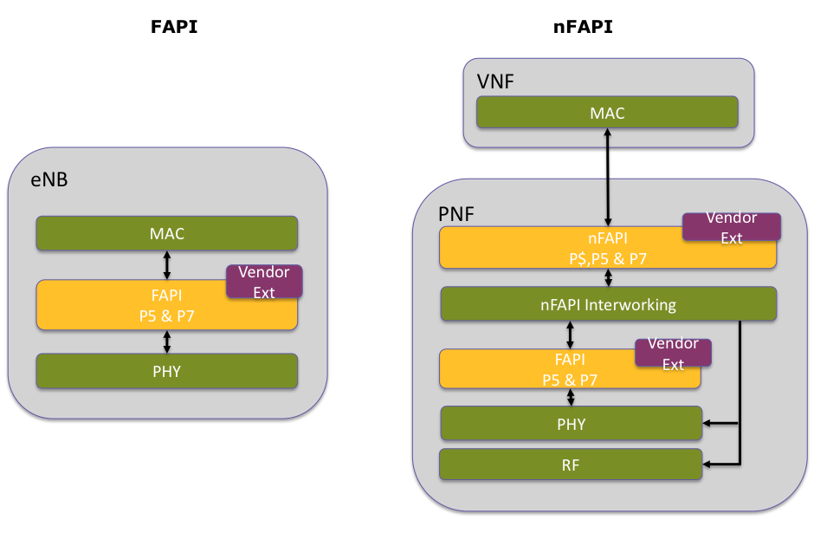

Figure 1: FAPI vs nFAPI architecture
Most recently, the SCF has published the nFAPI interface definition as part of its Release 7 “HetNet” publications (http://scf.io/documents/082). Specifically, the VNF/PNF split is supported over 8 separate interfaces, labeled P2 through to P9 ,as illustrated in Figure 2 below. SCF082 then includes details of Small Cell Forum nFAPI definition for the supporting the P4, P5 and P7 interfaces.

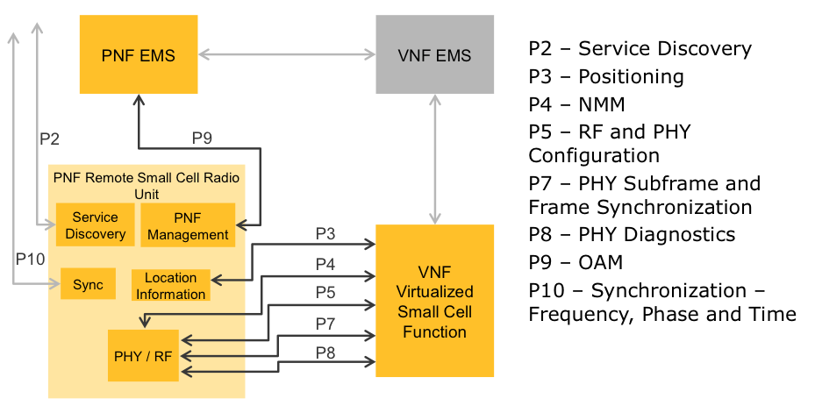
Figure 2: nFAPI Interfaces
Moving forward, the SCF is planning on publishing other material concerning small cell virtualization as part of its Release 8 deliverables, targeted for publication in Q4 2016. This release is planning on addressing:
- Aspects related to Operations and Management of the PNF that look to leverage existing TR-069 based Small Cell management capabilities.
- MANO and NFVI issues associated with accelerating virtualized RAN workloads.
- New opportunities to use small cell virtualization to support multi-operator use cases.,
- nFAPI enhancements to support release 13 capabilities including where Listen Before Talk functionality is co-located with the existing Network Monitor Mode (NMM) functionality in the PNF.

4. Request to IEEE 1914 Working Group
SCF asks IEEE 1914 Working Group to kindly consider the above as it moves to analyzing functional partitioning schemes between Remote Radio Units (RRUs) and Base-Band Units (BBUs).
From a use case perspective, SCF asks IEEE 1914 WG to kindly consider:
- The wide range of different deployment scenarios, where there may be a range of locations capable of supporting virtualized RAN workloads, all the way from centralized data center through to distributed, on-premise locations.
- The SCF analysis into different splits that concluded that there are various “sweet spots” in transport characteristics versus enhanced RF capabilities that motivate definition of three split options, namely MAC/PHY, PDCP/RLC and RRC/PDCP.
- The opportunity to use functional partitioning and associated virtualization of the upper layers in the vBBU to provide new capabilities to support multi-operator deployments, including shared PNFs that are connected to multiple VNF instances.

Next Meetings:
Small Cell Forum Plenary and Board Meeting: 12 September 2016, Rome, Italy
Small Cell Forum Plenary and Board Meeting: 02 November 2016, Dallas USA

