IEEE Learning Technology Standards Committee Meeting
Monday, July 31, 2017, Alexandria, VA

This face-to-face meeting was held at the Institute for Defense Analyses, 4850 Mark Center Drive,
Alexandria, VA.

Participating Today

Avron Barr, Independent
Frank Polster , G3
Mitchell Bonnett, US Army TCM TADLP
Hamadou Saliah-Hassane, TELUQ University & IEEE P1876
Robby Robson, Eduworks Corporation
Jonathan Goldberg, IEEE Standards Association
Andy Johnson, ADL
John Rogers, US Military Academy
John Costa, Repubit LLC
Damon Regan, Independent
Elliott Robson, Eduworks Corporation
Fritz Ray, Eduworks Corporation
Marsali Hancock, DQ Institute

Regrets

Paul Lefrere, CCA

Agenda

8:00: Coffee and registration, Room 1313

8:30: LTSC business meeting

- Roll call, establish quorum (Frank Polster, Secretary)
  - The current membership roster.
  - Regular attendance is required to be a voting member.
  - We do not have a quorum at this meeting. Decisions will be deferred to the September meeting.

- Review and approval of today’s agenda. Please feel free to add notes during the meeting.

- Review and approval of our last meeting’s minutes. The notes and recording from the June meeting are here.

- Call for related patents. Please familiarize yourself with these antitrust and IP guidelines for IEEE meetings.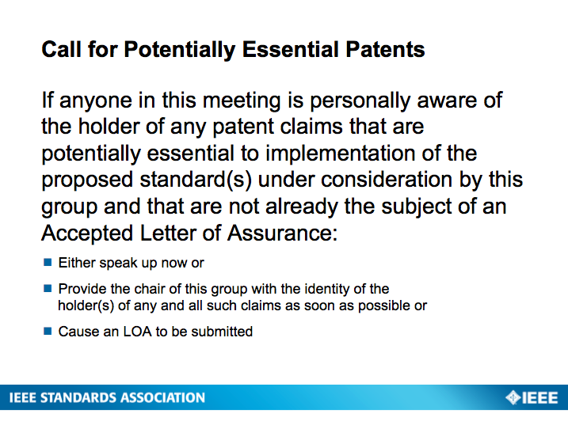
5. Possible changes to LTSC P&P’s, including annual membership fees
- Most sponsoring committees do not have annual fees, but charge for face-to-face “site” meeting attendance.
- Fees could cover our small web presence, handout materials, etc. expenses
- Proposal: decide at September meeting about fee between $25-$100.
- Meeting sponsorship is an alternate method of raising funds.
- The Chair might have discretionary power to lower or waive the annual fee if it would be a financial hardship.
- Meeting fee could be applied toward the annual LTSC fee
- To count toward quorum, you have to be a paid member and attending monthly meetings regularly. This defines “voting membership” in the LTSC.
- The LTSC P&Ps will need to be re-approved next year, with a new SA baseline P&P available in 1Q18.

6 . Ideas for the new LTSC landing page (Frank Polster, Secretary)
- New Wordpress template at http://sites.ieee.org/sagroups-ltsc/
- Other LTSC websites
  - http://www.ieeeltsc.org/ (pointed to by www.ieee-ltsc.org)
  - https://ieee-sa.imeetcentral.com/ltsc/
  - https://www.computer.org/web/sab/learning-technology
  - https://ieeeltsc.wordpress.com/
- Frank is cleaning up the old websites and will produce a draft of the new site this fall.
- If you want to help or propose content for the website, please contact Frank.

7. SC36 and the TAG
- The LTSC has a formal liaison relationship with ISO/IEC JTC 1 /SC 36
- In the US, ANSI appoints Technical Advisory Groups to represent the US in ISO as a voting member.
- The issue is whether we should propose a US national body, e.g., the LTSC. But the IEEE is an international organization, not a U.S. organization.
- Since ISO is very influential in government policy affecting education and training, the liaison relationship has be very important in the past.
- This issue will be revisited when a solution is proposed.

8. Free standards for education
- We will discuss in September the possible ways to fund a “freemium” model for LTSC’s standards, e.g., the IEEE GET program.

9. Liaison with the VR/AR WG (https://standards.ieee.org/develop/wg/VRAR.html)
- The LTSC’s ARLEM WG (P1589) has balloted a spec for describing an augmented working environment.
- AR and VR are in high demand in US military training organizations
- Key issue for the Dod: How can VR/AR learning activities produce assessments of learners’ mastery level that can be tracked in an LMS or other system?
- The ADL’s xAPI serious games profile might be relevant to the VR/AR specs.
- The LTSC could become a co-sponsor of the VRAR WG, and/or one of us could become a participant in the VRAR WG.

10. Relation of LTSC work to other standards activities
- Relevant standards that might emerge in the coming years:

  - Competencies: frameworks, student model, evidence (update to IEEE Reusable Competency Definitions, 1484.20?)
  - Activity metadata for AI agents (update to LOM, IEEE 1484.12?)
  - Context/situation of learner: devices available, schedule, ….
  - eReader for an Actionable Data Book
  - Guidance for student data governance (IEEE 7004)
  - xAPI/LRS, IMS Caliper, or something else about learning activity data collection, storage, management, and analysis.
  - Update to Learning Technology Systems Architecture (IEEE 1484.1)
  - Networked Smart Learning Objects for Online Laboratories (IEEE P1876)
  - GIFT-based ITS standards, including ITS-as-a-service
  - Personal Data AI Agent (IEEE P7006)
- The LTSC might produce a guide to other standards vis a vis their relevance to learning technology with recommendations about their application
  - John and Andy will write up an initial description of this project to be reviewed by everyone, and Marsali will try to find sponsorship.
- A revision to 1484.1 would be timely and would help position the LTSC as a thought leader in the new learning technology ecosystem.

10. Marsali Hancock: Child and Student Data Governance Working Group (P7004)
- Goal: produce standards for vendors and educational institutions that will assure stakeholders about specific constraints on the collection, storage, distribution, and use of student data

11. Robby Robson: Actionable Data Book eReader specification Study Group
- IDPF’s EPUB3 is now managed by a publishing group within the W3C
- IMS, Marcus G., has a WG that is looking at extending EPUB3 with their Caliper and LTI specs, to contribute to EPUB.
- LTSC has two options
  - Figure out how the TLA stack and EPUB interact
  - Look at PEBL (Eduworks IP) and ADB (IEEE IP) and other projects to propose new spec based on EPUB to allow the ADB/PEBL affordances, remaining agnostic about xAPI vs. Caliper, etc.
- See www.peblproject.org

Our next meeting will be on Tuesday, September 12th at 9:00am Eastern.
To register for the meeting and/or the dinner, please click here. Questions to chair@ieee-ltsc.org.

