ROOM RESERVATION REQUEST FORM FOR PARTICIPANTS
OF IEEE 1914 WG
(Valid from 07 Oct 2019 – 11 Oct 2019)

Kindly fill up details in RED (*) column and delete where necessary.
COMPLETE DETAILS IN FULL
*Title: | Choose an item.
*First Name: |  | Passport No:
*Last Name: |  | Job Title:
*Arrival Date: |  | Flight Details Arrival:
*Departure date: |  | Flight Details Departure:
Email: |  | Reservation made on (date)
Company:

Room Type  (Refurbished) | Rates (Single) |  | Rates (Double)
Deluxe Plus Room  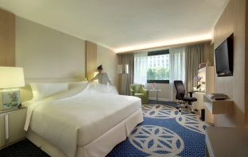 | S$218.00++ per room per night  - Daily breakfast for 1 persons  - Free Wi-Fi connectivity for multiple devices | ☐ | S$233.00++ per room per night  - Daily breakfast for 2 persons  - Free Wi-Fi connectivity for multiple devices | ☐
Premier Club Room  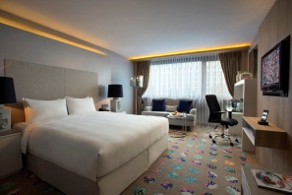 | S$258.00++ per room per night  (inclusive of club benefits)  - See list below | ☐ | S$278.00++ per room per night  (inclusive of club benefits)  - See list below | ☐
All the rates are in Singapore dollars and are subject to 10% service charge and 7% GST unless specified as nett. All bookings must be made directly with the hotel. In the event of a revision of rates within the year prior notification will be given.

BENEFITS OF PREMIER CLUB ROOMS
- Complimentary minibar (replenishment will be done once daily)
- Personalized check-in and check-out at the Premier Lounge.
- Extended check-out time upon availability.
- Choice of complimentary breakfast for every registered guest in any of the 3 venues:
- Premier Lounge, Spices Café or Room Service Complimentary use of Premier Lounge meeting room for 2 hours per stay. Subsequent hours are chargeable.
- Complimentary Wi-Fi connectivity for multiple devices for all guests and at the Premier Lounge excluding the meeting room. Complimentary laundry or pressing of two (2) pieces daily per room which is non-accumulative (excludes dry cleaning) Evening Cocktails; including beer and house pouring wines. Guests are entitled to invite only one guest for Evening Cocktails.

Options of Payment Method (Credit Card or TT):
*CREDIT CARD GUARANTEE
☐ Master |  | ☐ Visa |  | ☐ American Express
Card No: |  |  | Expiry Date:
Cardholder’s Name: | Enter your first name
*Please provide credit card details to guarantee your bookings. Kindly note that for guaranteed reservations at time of booking, rooms are held until hotel check-out time the day following arrival and non-guaranteed reservations will be subject to 6pm release on the day of arrival.

CANCELLATION POLICY
The Hotel reserves the right to charge for the individual guest for the full duration of stay for any cancellation or release of rooms made after 2 days (48 hours) prior arrival date for guaranteed bookings.
Please be advised that your reservations will only be deemed as confirmed when you have received this form back from our Reservations Department with the confirmation number given.

RESERVATIONS ASSISTANCE
For any assistance, please contact us via email or telephone to any of the following:
Reservations Department: Email - Direct tel: +65 67398303/043 8855 / Hotel General Tel: +65 67338855
Delphina Tan (Sales Secretary): Email: delphina.tan@concorde.net Tel: +65 6739 8365
Momoko Sumiya (Sales Manager: Email: momoko.sumiya@concorde.net Tel: +65 6739 8323

