IEEE P1936.1 & P1937.1 & P1939.1 WGs

The 2nd Face-to Face Meeting

To be held on 31 July, 2019, Suzhou (China)

General Information

1. Meeting Date
2019年7月31日
July 31, 2019

2. Meeting Location
会议地点：
苏州金鸡湖国际会议中心A馆(SZJICC)
苏州工业园区苏州大道东688号

Venue：
Suzhou Jinji Lake International Convention Centre (SZJICC)
688 E. Suzhou Avenue, Suzhou industrial Park, Suzhou, Jiangsu Province, P.R.China

3. Meeting Hour
The normal meeting hours will be as follows (unless otherwise decided by Chairman or Secretary):
From 9:00am-12:00am
From 1:00pm-5:00pm
There will be official coffee break. Coffee/tea and cold drinks will be available in the meeting room.

4. Transportation
The nearby Airports：
- Sunan Shuofang International Airport, IATA: WUX, ICAO: ZSWX (about 43 km. It will take about 44mins and 121RMB by taxi from the airport to the meeting venue)
- Shanghai Hongqiao International Airport, IATA: SHA, ICAO: ZSSS (about 72 km. It will take about 1hr and 15mins and 200RMB by taxi from the airport to the meeting venue)
- Shanghai Pudong International Airport, IATA: PVG, ICAO: ZSPD (About 130 km)

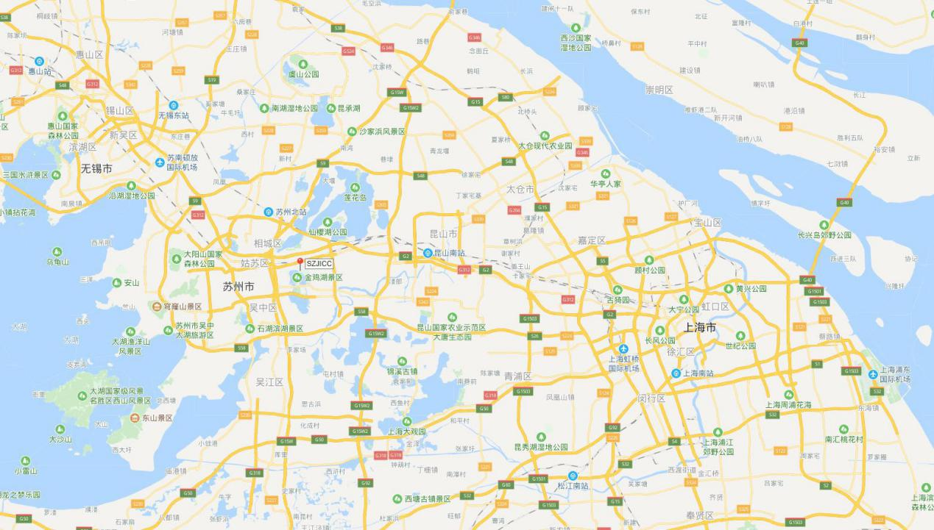
Sunan Shuofang International Airport

Suzhou Jinji Lake International Convention Center (SZJICC)

Shanghai Hongqiao International Airport

Traffic Information:
- Subway: take Line 1 and get off at Cultural Exhibition Center (文化博览中心) Station, then walk 350 meters.
- Bus: take fast line 2 and get off at International Exhibition Center(国际博览中心) Station, then walk 213 meters.

5. Meeting Registration
Delegates need to send the Registration Form back to the organization group via
Email：ymai2012@126.com
Please download and complete the Registration Form which is attached for your convenience.
The deadline for the registration is July 19. Nevertheless, delegates who need to reserve a room are kindly requested to confirm your reservation no later than 2 weeks before the meeting.

5. Accommodation
Agreement Hotels around SZJICC
No. | Hotel | Star-rated | Distance (km) | Room Reservation | Location
1 | Novotel Suzhou Sip Hotel  苏州文博诺富特酒店 | ☆☆☆☆ | Adjoining | WEI Peipei  魏培培  18601231980 | No.688 Suzhou Avenue East, 215027, Suzhou, Jiangsu Province, China
2 | Jinji Lake Shilla Hotel  金鸡湖新罗酒店 | ☆☆☆☆☆ | 1.5 |  | Modern Piaza, Wang Dun Road, Suzhou Industrial Park 215028, Suzhou, Jiangsu Province, China
3 | Courtyard By Marriott Suzhou  苏州万怡酒店 | ☆☆☆☆☆ | 2.5 |  | 188 Xinghai Street (Xinghai Jie), Suzhou Jiangsu Province, China
4 | Holiday Inn Express Suzhou Industrial Park  苏州工业园区智选假日酒店 | ☆☆☆☆ | 5 |  | No.999 Zhongxin East Avenue, Suzhou Industrial Park , Suzhou, JS 215028, Suzhou Jiangsu Province, China

Meeting participants can choose to contact WEI Peipei (18601231980) to reserve a room to get an agreement price.

6. Climate
It is the midsummer at the end of July in Suzhou, the weather is hot, The temperature is normally 35℃ during the day and 28℃ at night then. Please check out the weather condition before your departure.

7. Electricity

The Chinese standard for electric power is 220 Volts or 50HZ. Most outlets take two flat plugs or three flat plugs

8. Contact
If you have any questions, feel free to touch with the contact of the meeting.
Name: Ying Mai
Email: ymai2012@126.com
Tel: 86 13466769909

