Instructions of “Joinme” meeting system

1. Notes
- Connection test：Dial in >Client access > Web access（Google chrome or Firefox instead of 360 browser is recommended to ensure conversation effect）
- To ensure you have a better meeting experience, we recommend that you download the client in advance as following address：
https://www.join.me/Download.aspx?installer=win&webdownload=true
- Please connect the meeting 10 minutes in advance and adjust the headset
- Please change the name of "You" to "name-unit" after accessing the conference system.
- Please select “Mute” mode when you do not speak during the meeting to avoid noises.
- Please state your identity, name and unit before you speak to facilitate the minutes.

2. Steps

2.1 Client
Step 1: It would be more convenient to download and install "join.me.exe".
Download link:
https://www.join.me/Download.aspx?installer=win&webdownload=true
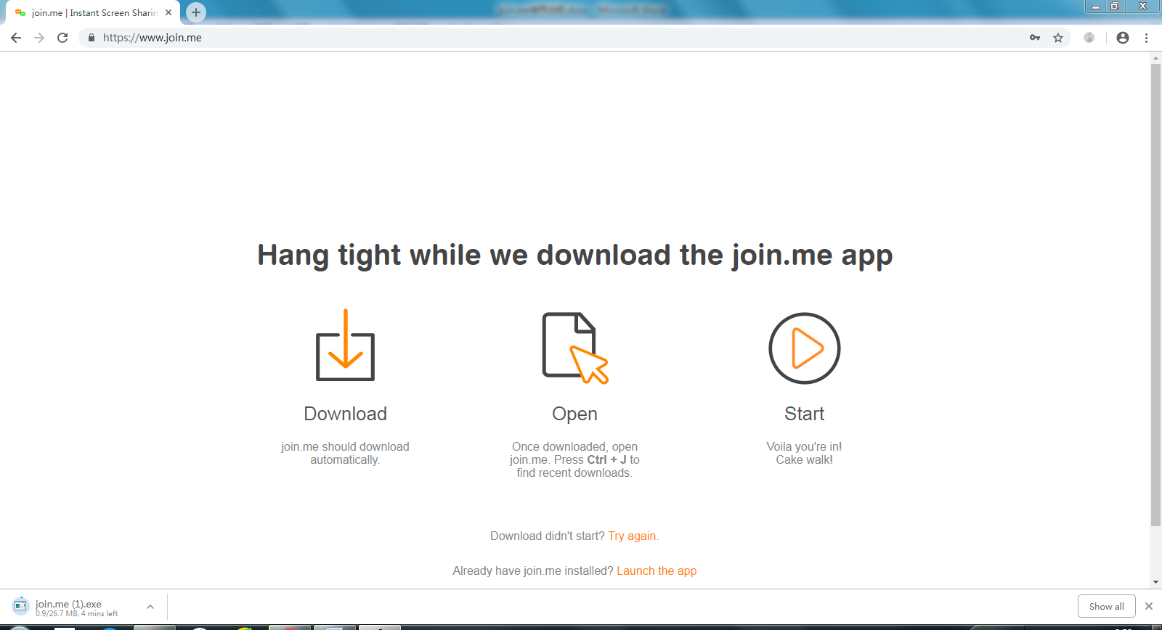
Step 2. Open Join.me and type in the meeting conference ID "217-854-881", (without registration)
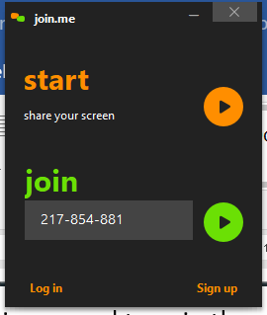

Step 3. The setting of the software is as follows:
Audio: click on the audio button
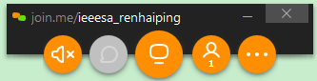
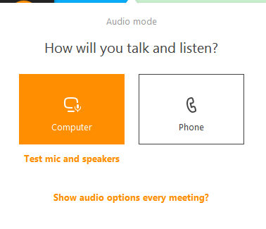
Step 4. Click "Test mic and speakers"
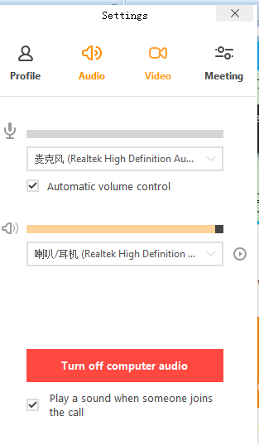
Step 5. Turn on computer audio and you are ready to use the microphone on your laptop.
Video: switch to "video" and turn on your webcam.
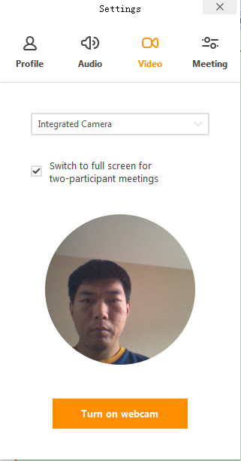
Step 6. Screen sharing:
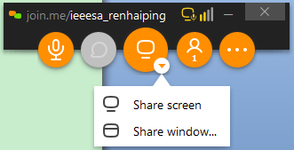

2.2 Web
Step 1. Visit website: https://www.join.me/
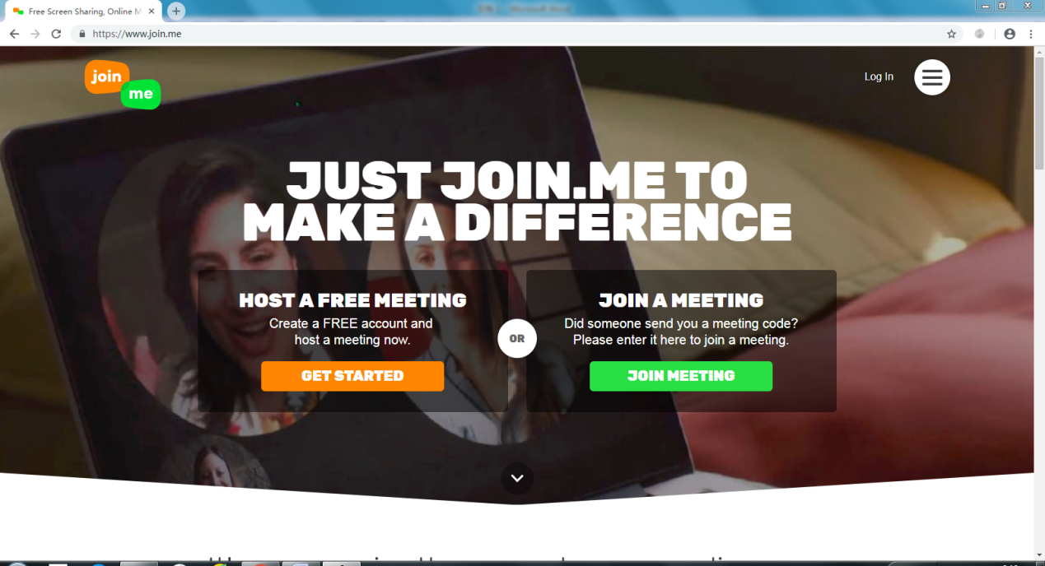
Step 2. Click "JOIN MEETING" and type meeting conference ID "217-854-881"
Step 3. Type your name and send a request by clicking "JOIN"

2.3 Dial in
United States - Boston, MA | +1.857.444.6500
United States - Cambridge, MA | +1.857.706.3435
United States - Camden, DE | +1.302.202.5900
United States - Denver, CO | +1.720.650.5050
United States - Los Angeles, CA | +1.213.226.1066
United States - New York, NY | +1.646.307.1990
United States - New York, NY | +1.646.749.3135
United States - Salt Lake City, UT | +1.801.448.0006
United States - San Francisco, CA | +1.415.594.5500
United States - Seattle, WA | +1.206.636.0011
United States - Tampa, FL | +1.813.769.0500
United States - Washington, DC | +1.202.602.1295
Argentina - Buenos Aires | +54.11.5352.8217
Australia - Central-West | +61.8.7282.4006
Australia - North-East | +61.7.3150.4013
Australia - South-East | +61.3.8820.4056
Australia - Sydney | +61.2.9191.6319
Austria - national | +43.720.881.959
Bahrain - national | +973.1619.9273
Belgium - Brussels | +32.2.808.8662
Brazil - Belo Horizonte | +55.31.3500.5101
Brazil - Brasilia | +55.61.3550.0430
Brazil - Curitiba | +55.41.3500.2121
Brazil - Porto Alegre | +55.51.3500.1401
Brazil - Rio de Janeiro | +55.21.3500.1441
Brazil - Sao Paulo | +55.11.4130.1068
Brazil - Sao Paulo | +55.11.3198.1366
Bulgaria - Sofia | +359.2.437.2476
Canada - Brantford | +1.226.401.9363
Canada - Charlottetown | +1.902.200.0149
Canada - Edmonton | +1.587.782.7458
Canada - Montreal | +1.514.800.1233
Canada - Ottawa | +1.613.714.4461
Canada - Quebec | +1.581.705.4251
Canada - Saskatchewan | +1.306.400.1019
Canada - Toronto | +1.647.977.2648
Canada - Vancouver | +1.778.654.8779
Canada - Winnipeg | +1.204.500.0399
Chile - Santiago | +56.22.582.8713
China - Beijing | +86.10.8783.3389
Colombia - Bogota | +57.1.508.6929
Costa Rica - national | +506.4001.5382
Croatia - Zagreb | +385.1.775.7101
Cyprus - Nicosia | +357.22.008854
Czech Republic - Prague | +420.228.881.313
Denmark - national | +45.6991.8003
Dominican Republic - Santo Domingo | +1.829.607.2080
Finland - Helsinki | +358.9.4259.9698
France - national | +33.9.7518.1777
France - Paris | +33.1.8288.3590
Germany - Berlin | +49.30.2240.3071
Germany - Cologne | +49.221.982.0381
Germany - Frankfurt | +49.69.9753.3131
Greece - Athens | +30.21.1198.2986
Hong Kong - national | +852.5808.1760
Hungary - Budapest | +36.1.700.8899
Ireland - Dublin | +353.1.531.4868
Israel - Tel Aviv | +972.3.763.0434
Italy - Milan | +39.02.9475.2989
Italy - Rome | +39.06.8339.9900
Japan - Tokyo | +81.3.4579.5983
Korea, Republic of - South Korea | +82.26.022.2310
Latvia - Riga | +371.6616.3227
Lithuania - Vilnius | +370.521.40705
Luxembourg - national | +352.20.880.005
Malaysia - Kuala Lumpur | +60.3.9212.1197
Malta - National | +356.2778.1234
Mexico - Guadalajara | +52.33.4162.2240
Mexico - Mexico City | +52.55.4631.9922
Mexico - Monterrey | +52.81.4770.1958
Netherlands - Amsterdam | +31.20.808.3218
New Zealand - Auckland | +64.9.951.8390
New Zealand - Christchurch | +64.3.288.0243
New Zealand - Wellington | +64.4.488.0310
Norway - Oslo | +47.2.396.1004
Panama - Panama City | +507.836.5977
Peru - Lima | +51.1.707.5722
Poland - Warsaw | +48.22.397.0104
Portugal - national | +351.308.800.816
Puerto Rico - San Juan | +1.787.773.1830
Romania - Bucharest | +40.31.630.2291
Russian Federation - Moscow | +7.495.777.3554
Singapore - national | +65.3158.1842
Slovakia - Bratislava | +421.2.3345.6680
Slovenia - Ljubljana | +386.1.828.0252
South Africa - Johannesburg | +27.10.500.9591
Spain - Barcelona | +34.93.220.1484
Spain - Madrid | +34.91.123.0202
Sweden - Stockholm | +46.8.4030.9107
Switzerland - Zurich | +41.43.508.1539
Thailand - Bangkok, | +66.2.026.8101
Turkey - Istanbul | +90.216.900.2525
Ukraine - Kiev | +380.443.92.0739
Ukraine - national | +380.893.23.9951
United Kingdom - Cambridge | +44.1223.85.9774
United Kingdom - London | +44.20.3582.4515
United Kingdom - Manchester | +44.161.820.1607
United Kingdom - National | +44.33.0088.2634
Venezuela - Caracas | +58.212.710.2107

