IEEE P1936.1 & P1937.1 & P1939.1 WGs

The 4th Face-to-face Meeting To be held on Feburary 27, 2020, Shanghai (China)

General Information
- Meeting Venue

The meeting will be held at Shanghai Lingang science and Technology Innovation City Economic Development Co., Ltd
Room 528 and 530, 5th floor, No.399, Haiyang 1st Rd, Lingang New area, Shanghai Pilot Free Trade Zone, China.
会议地点：上海临港科技创新城经济发展有限公司
中国（上海）自由贸易试验区临港新片区海洋一路 399 号 5 楼528、530会议室

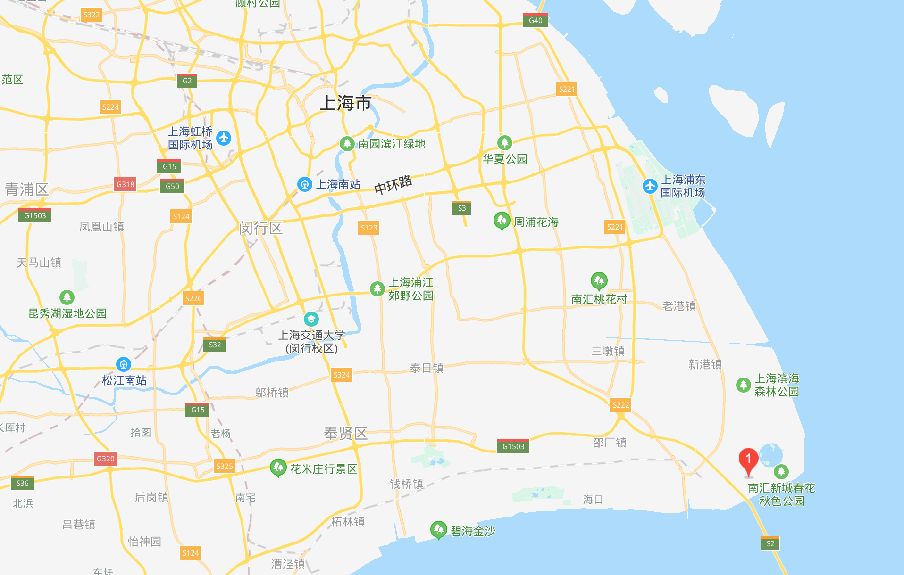
shanghai hongqiao international airport

shanghai pudong international airport
meeting venue: No.399, haiyang 1st rd, lingang new area, shanghai pilot free trade zone

2. Meeting Hour
The normal meeting hours will be as follows (unless otherwise decided by Chairman or Secretary):
From 9:00am-12:00am
From 1:00pm-5:00pm
There will be official coffee break. Coffee/tea and cold drinks will be available in the meeting room.

3. Accommodation
Meeting participants can choose to reserve a room in Crowne Plaza Shanghai Harbour City at a group price standard single king room 480 RMB. It would be adjusted according to the actual situation by then. Please present the booking code of IEEE 679 Meeting upon check in to enjoy the group price.
Hotel: Crowne Plaza Shanghai Harbour City
Address: No. 1 South Island, Harbour City, Pudong New Area, Shanghai
名称：上海滴水湖皇冠假日酒店
地址：上海市浦东新区南汇新城海港大道南岛1号
Website : https://www.ihg.com.cn/crowneplaza/hotels/gb/en/shanghai/shgwr/hoteldetail

4. Meeting Registration
Delegates need to make the registration both on-line and send the Registration Form back to the organization group via

Email: sparkl.xiao@skysys.cn
Please download and complete the Registration Form which is attached for your convenience.
The deadline for the registration is Feb 15th 2020. Delegates who need to reserve a room are kindly requested to confirm your reservation no later than 2 weeks before the meeting. Please tick at your choice in the Registration Form.

5. Transportation

From Shanghai Pudong International Airport to Hotel
Hotel: Crowne Plaza Shanghai Harbour City
Address: No. 1 South Island, Harbour City, Pudong New Area, Shanghai

By Taxi (Recommended)
The hotel is about 49 km away from the airport to hotel, and it will approximately take about 75 mins, and 140 RMB. Please show the following Chinese address to the Taxi driver.
名称：上海滴水湖皇冠假日酒店
地址：上海市浦东新区南汇新城海港大道南岛1号
By Public Transport:
Get on Line 2 at Airport station, take 11 stops then change to Line 16 at Longyang Road Station, after 12 stops change to Bus 1043 at Dishuihu Subway Station, after 4 stops, get off at Haigang Avenue Station, then walk about 900 meters. It will take about 110 minutes, and 13 RMB.

From Hongqiao International Airport to Hotel

By Taxi (Recommended)
The hotel is about 88.8 km away from the airport to hotel, and it will approximately take about 80 mins, and 323 RMB. Please show the following Chinese address to the Taxi driver.
名称：上海滴水湖皇冠假日酒店
地址：上海市浦东新区南汇新城海港大道南岛1号
By Public Transport:
Get on Line 2 at Airport station, take 16 stops then change to Line 16 at Longyang Road Station, after 12 stops change to Bus 1043 at Dishuihu Subway Station, after 4 stops, get off at Haigang Avenue Station, then walk about 900 meters. It will take about 120 minutes, and 15 RMB.

From Hotel to Meeting venue
The meeting venue is 3.6 km away from the hotel. And there will be a shuttle bus supplied at 8:30 am on 27th .
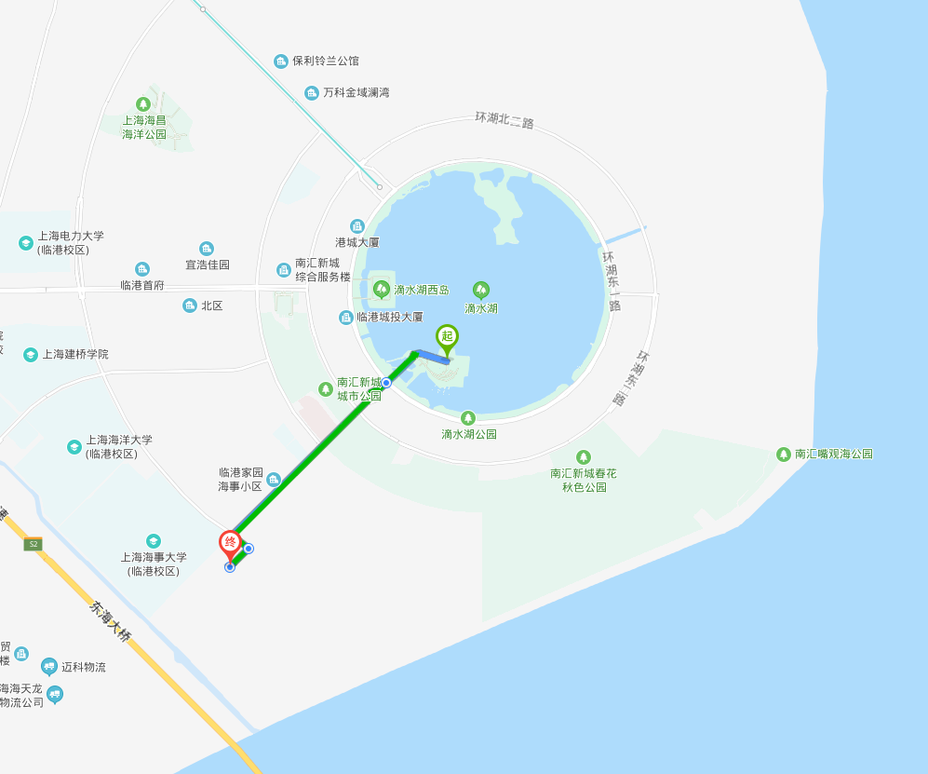

6. Climate

From mid-February to March, the weather of Shanghai will be a little cool and the sky will be bright and clear. The average low and high temperatures are respectively 4°C (39.2°F) and 10°C (50°F) in February, and 8°C (46.4°F) and 16°C (60.8°F) in March.

7. Electricity

The Chinese standard for electric power is 220 Volts or 50HZ. Most outlets take two flat plugs or three flat plugs

8. Contact
If you have any questions, feel free to touch with the contact of the meeting.
Name: Sparkl Xiao（肖建荣）
Affiliation: Skysys intelligent technology (Suzhou) Co. Ltd. （星逻智能科技（苏州）有限公司）
Email: Sparkl.xiao@skys.cn
Tel: 86 18616751168

