IEEE-ADWG, P3412 Program Survey

Name:
Company:
Title:
Contact:

High level descriptions of ADA framework. See FIGURE 1 for more information.
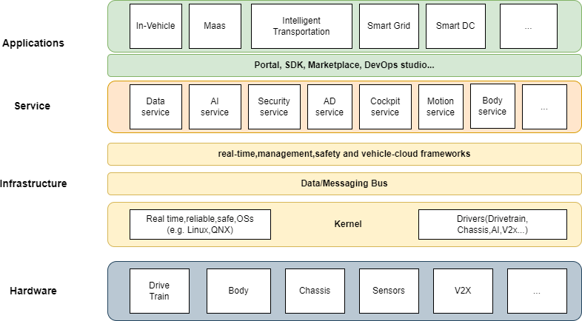
- AUTONOMOUS DRIVING ARCHITECTURE (ADA)

1. Do you think the implementation of Level 2 to Level 4 intelligent driving can have a common, unified system architecture?

2. Do you believe that the architecture of intelligent driving can achieve decoupling of software and hardware, as well as decoupling of system software and application software?

3. If decoupling software and hardware for intelligent driving, what do you think is the biggest challenge?

4. If designing the operating system architecture for intelligent driving, what kind of interfaces would you like to provide?

5. Regarding functional safety, how do you think the architecture of intelligent driving should be designed?

6. Regarding information security, how do you think the architecture of intelligent driving should be designed?

7. Do you think the real-time performance of autonomous driving needs to be ensured by the user or by the operating system?

8. How do you think the unified implementation between the architecture of intelligent driving and vehicle cloud computing can be achieved?

9. Do you think the implementation of the intelligent driving architecture needs to have an open-source version and be maintained by an open-source community?

10. Could you share your recent work direction and mass production plans in the field of autonomous driving and smart vehicles?

Remarks: Please send all feedbacks by email to Editor - Dr. Jin Shang (shangjin@gmail.com) and copy to Chair Dr. Dong Sun (dsun@ieee.org) before the deadline – April 07, 2024.

