# 2020 JTCM Meeting Minutes – Harmonics WG (519)

## Meeting Location and Time

Hyatt Regency Jacksonville Riverfront  
225 E Coastline Dr  
Jacksonville, FL 32202  
Grand Ballroom 2

2020 January 15  
8 AM – 9 AM

## MEEting Minutes

### Attendees

David Zech Kenn Sedziol

Nick Zagrodnik Rey Ramos

Mark Halpin Steve Tatum

Steven Johnston Dan Sabin

Kevin Kittredge Eugene Song

Joe Grappe Matt Norwalk

Bill Howe Joseph Sneed

Paul Ortmann Marlin Browning

Justin Kuhlers Gary Chang

Sarah Ronnberg Scott Peele

Bryan Glenn Patrick Chavez

Chris Mullins Greg Pagello

Gaurav Singh Tom Nelson

Anthony Murphy Floyd Medley

Harish Sharma Ji Soo Kim

Marty Page Ahmed Moustafa

Math Bollen

The meeting was called to order by David Zech at 8am. Minutes were recorded by Nick Zagrodnik.

### Old Business

IEEE mandatory legal slides were reviewed by the Chair. No patents were identified by the attendees.

Minutes from 2019 GM unanimously approved.

Draft 2 of 519 was sent out a few weeks prior to the meeting and received some initial comments already. Par expires 12/2021.

### New Business

Sara Ronnberg presented material on high frequency harmonic distortion, titled Supraharmonics and cable terminations.



Regarding accurately measuring high frequency distortion, Math Bollen commented that, through his phD work was in the 1980’s, it was shown by comparing measurements and simulations that resistive voltage divider type transducers are able to accurately pass frequencies up to 100 kHz.

Dave Zech prompted discussion from the group on whether to make IEEE 519 strictly a load-based standard or also include limits/direction for when inverter-based generation is downstream from the PCC of the installations being evaluated.

General consensus was to keep 519 a load-based standard and implement references to IEEE 1547 and IEEE 2800 (when published) in the document for installations that are purely generation (i.e. very little load).

Inclusion of limits and direction where an installation has a mix of harmonic producing loads and generation remains to be determined. It was suggested to use the flow chart graphics (H.1 and H.2) shown below from IEEE 1547 to make the decision.

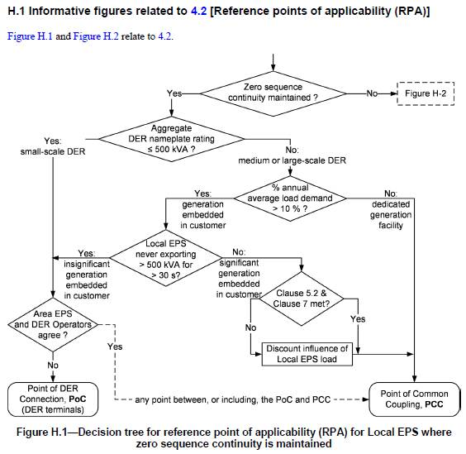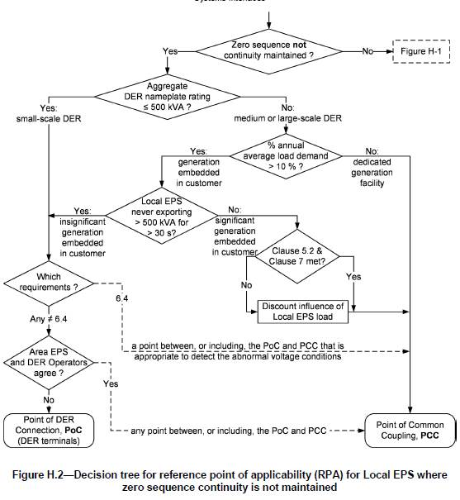

Dave Zech prompted discussion regarding that proposed and presented in latest draft of the IEEE white paper titled, Issues and Challenges Related to Interharmonic Distortion Limits, and made it a point to those in attendance that the Interharmonic TF requested feedback from 519 WG regarding content and proposal in interharmonic white paper Dave forwarded to the group.

Feedback:

* Sub-grouping methodology of non-integer sub-harmonics remains to be determined
* Effects of interharmonic distortion on non-lighting equipment not as well studied
* More restrictive at lower order (2nd order and below). Higher orders would most likely use limits of nearest integer harmonic limit as it is thought the effects on equipment of higher order interharmonics are similar to integer harmonics.
* Correlation between flicker and TID

Interharmonic TF proposes interharmonic voltage limits and to begin with an informative Annex in 519.

Mark Halpin suggested that the Annex has traditionally been forward looking with the potential goal of making it into the main body of the document.

Mark Halpin suggested we request Roberto Langella to draft Annex material on interharmonic limits. There was consensus that this was a good idea. Kenn Sedziol made a point that we could utilize the new IEEE country specific methodology that would allow countries to make changes to the standard as needed.

Dave Zech prompted discussion on establishing current distortion limits > 50th order.

Math Bollen brought up the point that the application of higher order harmonics is largely dependent on voltage level due to how higher order harmonics interact with various parts of the electric grid (i.e. transmission vs distribution). He also pointed out that the propagation of higher-order harmonics is fundamentally different from the propagation of lower-order harmonics. The relation between voltage and current limits, as assumed for lower-order harmonics, is no longer valid for higher-order harmonics. Because of this, we should not just extent the upper limit from h=50 to something higher.

General consensus is that establishing technically sound harmonic limits > 50th order is too premature to adopt before the balloting and publishing of next revision of 519.

Math suggested using the IEC method of having a section on limits under consideration (e.g. > 50th order).

Kenn Sedziol agreed, but prefers to have it in 519.1

Dave requested strawman poll of WG members for those in favor of rewording higher order limits to extend beyond the 50th.  There was not consensus in one direction.

Some voiced concerns that there still remain issues with how to properly analyze and measure higher order harmonic distortion due to frequency response of instrument transformers/PQ monitoring equipment. There is also the issue of how PQ monitors calculate THD. There needs to be an upper limit for that calculation (at least the way THD is currently calculated in 519).

Others countered that having something is better than nothing knowing that issues are beginning to crop up with distortion in that range. There needs to be a starting point.

Mark Halpin suggested that perhaps we restrict 519 to distortion limits less than or equal to 50th order and then start another WG/TF to develop a document that covers distortion above the 50th.

Another proposal is to remove the 50th harmonic restriction/cap in the individual harmonic limits in Tables 2-4, but in the THD/TDD calculations keep the 50th as the upper limit.

Meeting adjourned at 10:00 am

### Summary of Volunteers for Future Activities:

New and carryover Action Items from 2019 JTCM

1. (New) Roberto Langella’s interharmonics team to write material for informative annex to be placed in P519.
2. (Carryover) Gary Nuzzi, Nick Zagrodnik and Mark Halpin to write justification and proposal for new THD definition that would include/take into account integer and interharmonics up to 50th.
3. (Carryover) Gary Nuzzi, Nick Zagrodnik and Mark Halpin to write justification and proposal for TDD that clearly states definition of what type of demand measurement interval to use.
4. (Carryover) Bill Howe volunteered Tom Cooke to write a piece on current state and improving measurement technology to enable PQ monitoring equipment to accurately measure distortion above the 50th. This section should also include difficulties/limitations of accurately measuring harmonic distortion on HV systems due to instrument transformers.